Navigation Audit Reporting Module
A Quick Guide

1. Navigation Audit Reports

These reports will display the data related to the Navigational Audit. There are 13 reports in this module divided into 4 sections.
To Navigate to this module login into BI instance using the below url.
http://192.168.166.202:9704/analytics/saw.dll?bieehome&startPage=1

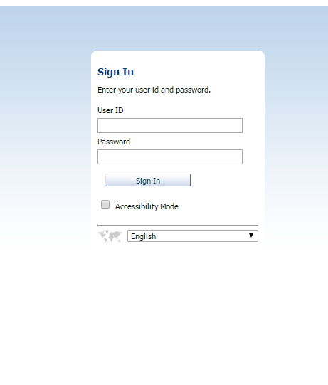

Enter the below Credentials
User ID : weblogic
Password : Welcome1

Once Logged in then navigate to the dashboards and select Port calls Dashboard

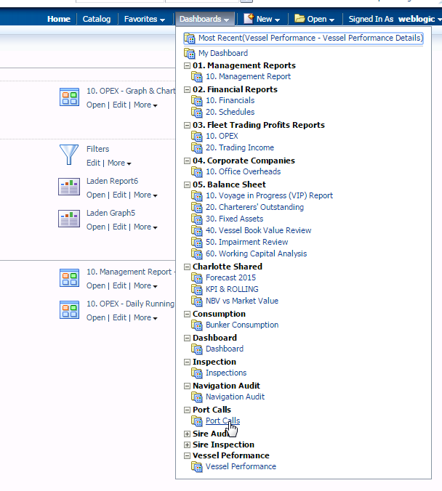

Select the Port Calls Map dashboard to view the map which shows the number of port calls by country
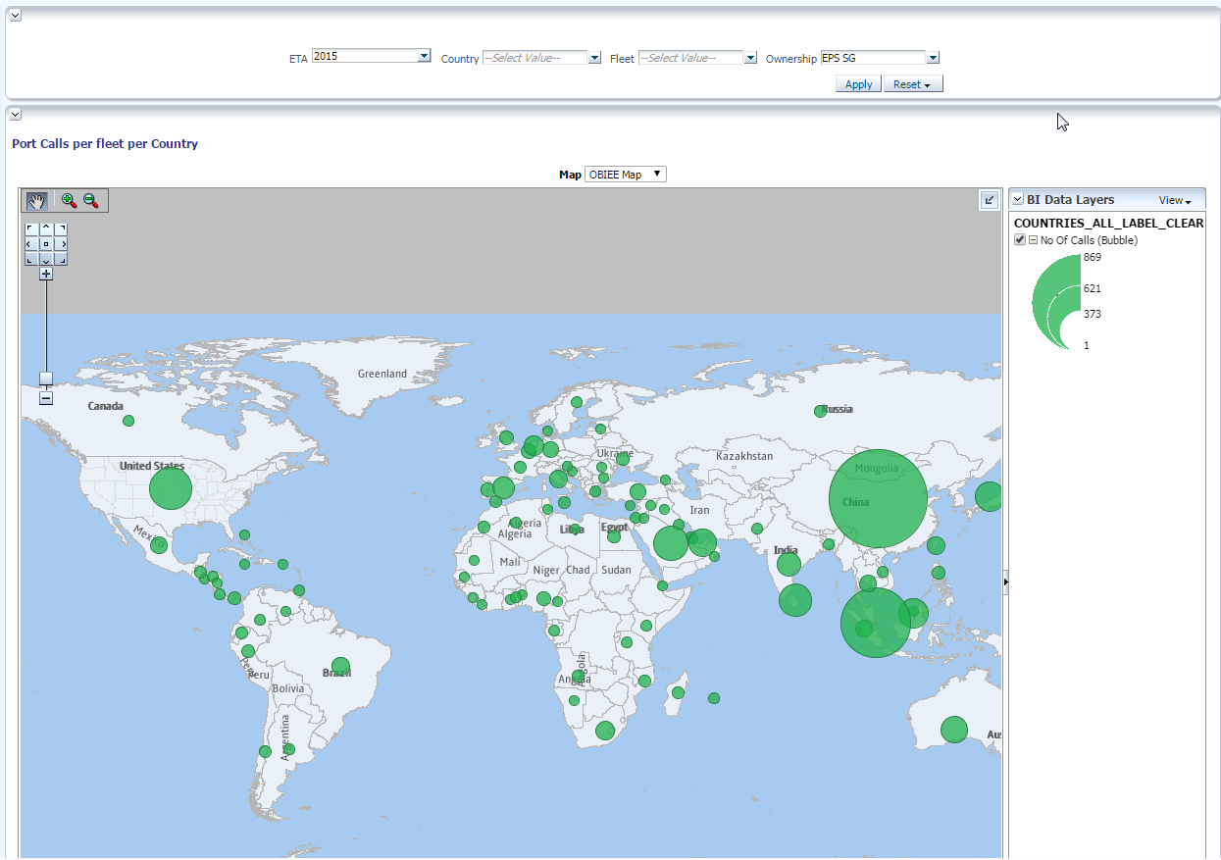

There is an option to select either OBIEE map or Google Maps.

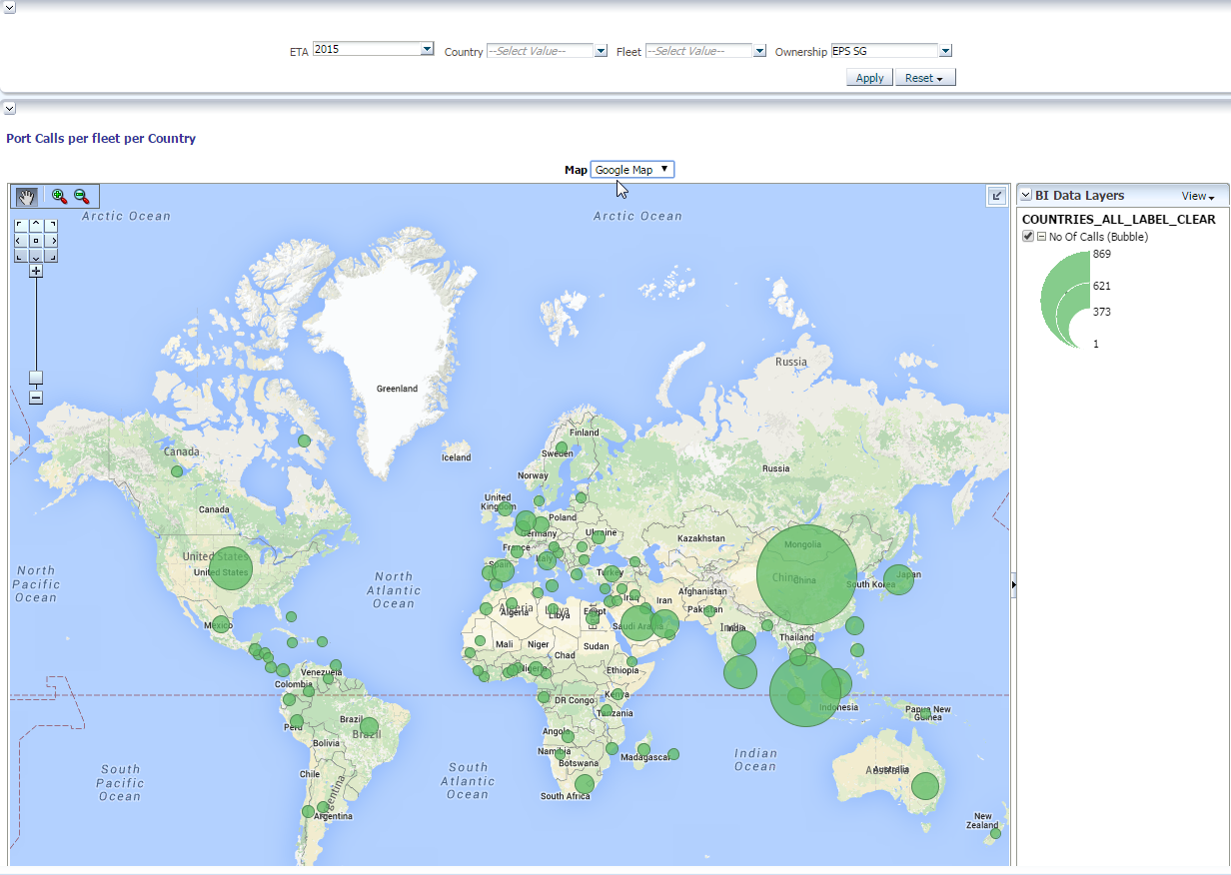

- Once logged in then click on the URL to navigate to the required report.
    - There are few Parameters for the each report. They are
        - Year : Select the year to view the data
        - Country : Select the country to view the port calls data.
        - Fleet Type : Select the type of fleet
        - Ownership : Select the ownership like ‘EPS-UK’ or ‘EPS-SG’

